EYES WIDE SHUT – OR EYES WIDE OPEN?
On May 21, 2020May 21, 2020 By Bradley Loves You
By: Bradley Loves

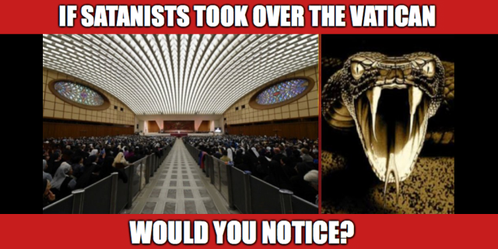

A few months ago Donald Trump declared March 15th 2020 to be a National Day of Prayer. He urged us all to worship in what ever way we could.
Unfortunately, I was raised a Catholic! My Dad still goes to Catholic Mass every Sunday, and he is 80 years old.
I refused to go!
How could I go knowing what I know about the criminal antics of Rome, and the foul dealings that the Catholic Church has with countless Luciferian & Satanic elements worldwide?
It has become very difficult for me to understand why so many people would willfully and willingly overlook these bad deeds and criminal acts simply because they have been “taught/trained/programmed” to believe in certain things.
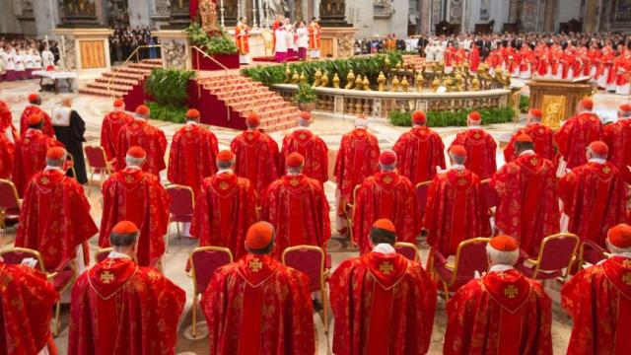

There is REAL EVIL moving around in our midst! It is being very cleverly “hidden” in a place that most people would NEVER think to look.
The Catholic Church is GUILTY of running a worldwide slavery racket that has broken every RICO law ever thought of and every put onto the books of justice.
The Birth Certificate/All Caps Name Con – which is the start of it all – goes right back to ROME!
Under the “disguise” of something called: SALVATION – which is another word for SALVAGE – The Catholic Church is running a world wide RICO CON which establishes (on paper) their ownership and false claim upon every single human body and human soul living here on the Earth!
Working in league with Dark Forces and Luciferian Secret Societies World Wide – the Vatican is at the epicenter of all Criminal Activity that takes place across the entire world.
It is the heart of the WHORE OF BABYLON.
Drug running and drug distribution worldwide, arms sales, human trafficking and prostitution make up the three biggest racketeering industries on the planet – and they have their hands in all of it.
They simply do it through countless networks of secular FRONT COMPANIES, SHELL CORPORATIONS and BANKING INSTITUTIONS which act as their arms and their legs in the world of crime.
Millions of men and women – for profit – have turned a blind eye to this criminality simply to live a comfortable life.

And yet, Christ, which is the manifestation of the love of the Creator here on Earth, wonders who has the moral courage and the ethical decency to stand up to what is truly a demonic control structure that sucks and saps the life energy out of billions of innocent souls world wide?
Not only is the Church involved in shady racketeering, but it’s lust for using Dark Magic to both hide and protect its operations, compels it to seek out and utilize the most innocent souls alive (our children) – in the most brutal ways imaginable to cast these Dark Magic Spells on an on going basis!
“The Roman Catholic Church” is the group that instituted CORPORATIONS in the first place and is the group who – through the HOLY SEE – instituted and over sees Admiralty Law/Maritime Law in all of the courts worldwide.
As Anna Von Retiz constantly says in her writings –THEY are the ones who could put a stop to it all – and THEY are the ones who constantly REFUSE to do so because they are not working for the people on Earth or for GOD – but instead they are working for LUCIFER and for a type of world wide control and domination that most people can not imagine!
THEY HAVE GIVEN THEMSELVES OVER TO THE NEW WORLD ORDER

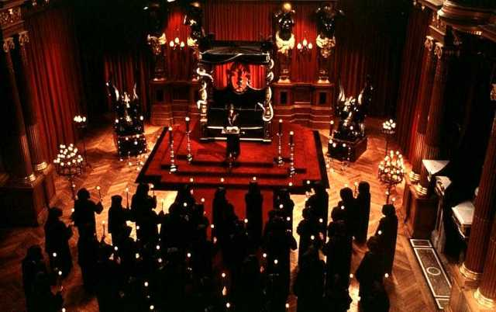
One of the most significant revelations to have ever come into public knowledge and given to us from escaped Generational Satanists like Jay Parker – is that Sex with little Kids – is considered to be a “SACRAMENT” in the Satanic/Luciferian Religion!
This means that in order to “practice” their religion properly – young children are very necessary “props” that MUST BE USED – so that the satanic worshipper can dutifully perform his or her sacrament to Satan.
This is done whether the child wants to participate or not! In other words – a huge part of the Satanic religion is FORCING other beings to do things that they don’t want to do!
I’ve mentioned this before – FREEWILL is not a consideration in SATANISM – ONLY BRUTE FORCE!

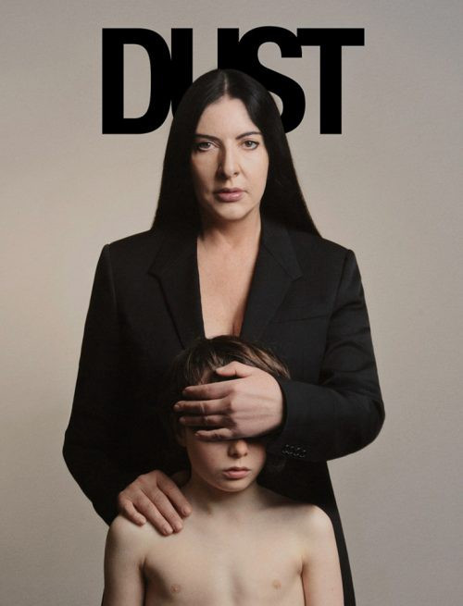
Now, if you’ve been watching what is going on in the world at all – and you’d really have to be TOTALLY BLIND to miss it – then you’d have noticed that most Governments in our world are moving closer and closer to SATANISM every single day – because they are ruling more and more every single day BY FORCE – and less and less daily by choice.
Choice is not an option here in 2020!
- You WILL give up your guns – or else!
- You WILL allow abortion at any age (even after the birth) – or else!
- You WILL speak only the correct words – or else!
- You WILL teach your children all about sex at five years old – or else!
- You WILL censor and ban anything kind of speech that we don’t like – or else!
- You WILL stay in your homes and self isolate – or else!
- You WILL stay 6 feet away from everyone and you will NOT GATHER – especially in churches of worship – or else!
- You WILL allow VOTE BY MAIL – or else!
- You WILL hate Donald Trump, just as the Media and Hollywood instructs you to – or else!
- You WILL be totally obedient to your Governors and do exactly what they say – or else!
- You WILL take every vaccination that we want you to take – or else!
- You WILL accept LUCIFER and SATAN as the GOD of this world – or else!
- You WILL accept adult/child sex and Ritual Child Sacrifice as normal – or else!
- You WILL accept that we EAT human flesh and DRINK human blood – or else!

GET THIS THROUGH YOUR HEADS PEOPLE – THIS IS WHERE IT IS ALL GOING!
BRUTE FORCE is the rule and the way in which the Satanic Religion is practiced!
It has always been practiced in this way! There is no room for FREEWILL and no room for FREE CHOICE!
The Luciferian’s and the Satanists have very cleverly kept HIDDEN their religion for many, many generations! They told you that it did not exist! They did this so that when they finally sprung the TRUTH on you – you’d be so off balance and so taken aback – that you would not be able to put a stop to their plans and they easily would win the battle for the Earth simply due to your complete lack of preparations for the battle.
Guess what?
THIS IS EXACTLY WHERE WE ARE PEOPLE – SO WAKE UP AND SEE IT FOR WHAT IT IS…
You’ve been had!
If you can not admit this to yourselves – and do the work necessary to wake up quickly and put a stop to this – ON YOUR OWN – then no one in the Universe is going to waste any effort trying to save you from Satanism!
There are enough people like me living on the Earth – and who are writing until our fingers are bleeding from hitting the keyboards of the computer for 8 hours every single day to give you adequate advance warning!
YOU ARE BEING TOLD!
If you choose – yes choose – to do nothing – then you will “get” the result of that choice – which is ENSLAVEMENT!

DIGGING DEEPER
It is my opinion that the VATICAN is actually harboring elements from OFF WORLD – and is being used as the battering ram to get the people of the Earth to stand down and accept an INVASION and a take over of the surface of the planet.
These “elements” may not even have corporal bodies, but instead be Demonic/Satan forces which can “possess” or “use” the bodies of those who are in charge and have power. Or, they may be human/alien hybrids who appear human but are not!
The “MOB” has become their hands and arms as they do their dirty work inside of every single country on the planet. They used gang members like MS-13 to do assassinations and take out people who are standing in the way of their agenda!
They have conscripted millions and millions of willing men and women into Secret Organizations and Secret Societies who are willing to go along with their AGENDA for a world wide takeover and establish a One World Government.
Their means are – out of necessity – totally 100 percent COVERT!
They act in the shadows and come at you from under the radar. They hold secret meetings in secret places – and no one who is not part of their plot – can gain access.
And yet – GOD IS WATCHING!
He has not left you alone to their devices and HE out of his love – has sent people onto the EARTH to warn you – because almost every single Priest, Pastor, and member of the clergy has ABDICATED their duty!
He has sent you messengers!
- However – you are not listening!
- You are not hearing what is being said!
Instead most of you are totally addicted to watching TV!
Most of you are paying constant lustful and despicable attention to “movie stars” and “rock stars” who have already given themselves over to Satan! Or worse, the Media!
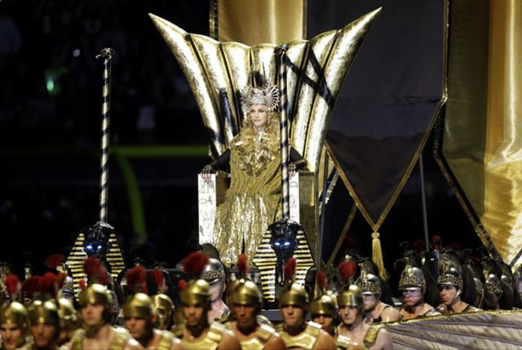
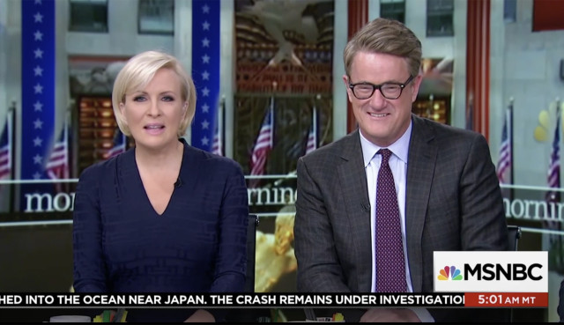
You are not listening to GODS messengers – and are instead buying tickets to rock concerts and movies filled with the AGENTS OF SATAN.
So what you are really doing then is listening to SATANS messengers – NOT GODS – and you are paying them huge amounts of money to lie to you!

YOU DO NOT WANT GODS HELP APPARENTLY – AND YOU ARE NOT HELPING YOUR OWN BROTHERS AND SISTERS WHO ARE STILL VERY UNAWARE OF WHAT IS COMING…
- You are worried about your paychecks!
- You are worried about your retirement!
- You are worried about your vacations!
- You are worried about your Social Security!
- You are worried about Medicare!
- You are worried about your nice home and your nice car, or about your Bank Account Balance!
You are worried about EVERYTHING that is meaningless – but you are NOT worried about GOD and your own eternal soul!
You are NOT WORRIED at all that there is a huge SATANIC takeover of the planet happening right in front of you – and so you sit in your home doing nothing and are terrified to even come out without a MASK!
YOU DO NOT WANT GODS HELP APPARENTLY!
I’ve said it before, and I will say it again – if and when the time comes – I have a way off the planet! I will not be here if and when this entire thing goes Satanic! I’ve done my job!
But as the Bible says:
Woe unto you who did not see the TRUTH – and were not willing put a stop to pure evil! In those days – you will wish you were dead – but you will not be able to die!
The lesson here is a very simple one:
You must be given – and you must see the consequence of your inaction!
You must be shown what happens when you literally take no action as the ship you are on – is sinking under you – or the home you are living in is set on fire and you do nothing to put out the flames!
Once GOD decides it is time – and that YOU have had enough warnings!
Then all of those who came here to warn you WILL SIMPLY LEAVE

